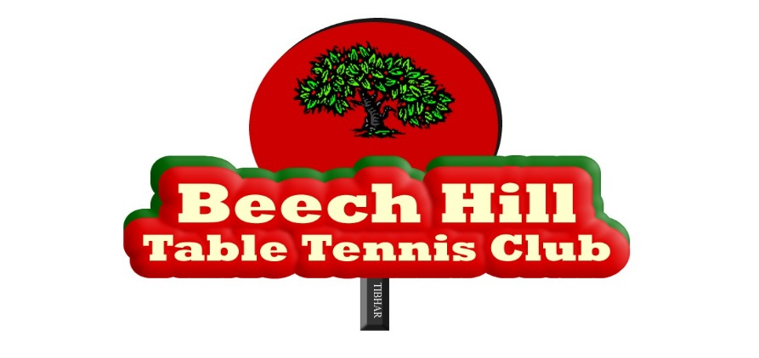

Safeguarding Statement
Beech Hill Table Tennis Club (BHTTC) provides table tennis training and competition for children and adults with an intellectual disability as part of its overall membership. BHTTC recognises the duty of care to safeguard and promote the welfare of children and vulnerable adults. The Club is committed to ensuring that our safeguarding practices reflect statutory and legal responsibilities, government guidance with best practice and Special Olympics and Table Tennis Ireland requirements.

As a club, we are confident that we are equipped and organised to protect the welfare of all athletes in line with the Special Olympics’ Code of Ethics and Good Practice and the Irish Sports Council’s Code of Ethics for Good Practice for Children's Sport and the Safety, Health and Welfare at Work Act, 2005.

The Club has an identified management structure to provide guidance for individuals who may have reasonable grounds for concern about the safety and welfare of people involved in BHTTC.

- The nominated person for safeguarding matters is the Club Safeguarding Officer Officers - CSO (TTI) – Charlie Billon - for mainstream player activities and CSO (SO) – Dan Horgan - for Wednesday night player activities. Their contact details are posted on the Club website.

- The Designated Liaison Person for the Club, who has the responsibility to liaise with the statutory authorities and national governing bodies, is the Club Chairman, Eoin Kelly, whose contact details are posted on the Club website.

The Club has undertaken a risk assessment and will continue to review the risks inherent with undertaking table tennis with children and persons with an intellectual disability.
Our Safeguarding Statement has been developed in line with requirements under the Children First Act 2015, (the Children First: National Guidance, and Tusla’s Child Safeguarding: A Guide for Policy, Procedure and Practice). In addition to our Risk Assessment described above, there are further procedures that support our intention to safeguard our players while they are availing of our activities. These procedures are contained in the Club Code of Ethics and involve:

• Procedures for the management of allegations of abuse or misconduct by coaches or volunteers against a player (s) availing of our activities

• Procedures for the safe recruitment of coaches and volunteers to work with our players in our activities

• Procedures for access to safeguarding training and information, including the identification of the occurrence of harm

• Procedure for reporting player protection or welfare concerns to Statutory Authorities

BHTTC recognises that implementation is an ongoing process. The Club is committed to the implementation of this Safeguarding Statement and the procedures that support our intention to keep players safe from harm while availing of our activities.

BHTTC, as part of its annual affiliation to Special Olympics Ireland and Table Tennis Ireland, has adopted this Statement and is committed to the implementation of best practice safeguarding procedures.

Chairperson of Club Management Team: 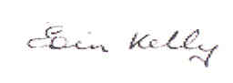

Club Safeguarding Officers:

Date:02/04/2018

