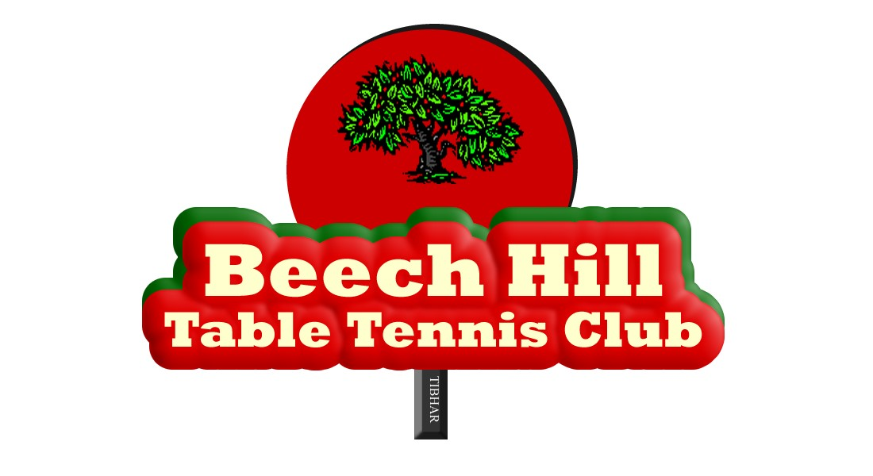

AGM 08/05/2026
Minutes
Present: Eoin Kelly, Philip Shaw, Scott McGowan, John Fitzgerald, Siraj Ahmad, Oonagh Cunningham
Apologies: Andrew Long, Fiona Sorensen, Amelia O’Connor, Christine McHahonl.

1. Minutes of last AGM were read out by Philip – no actions arising.

2. Financial Report. Scott delivered the Statement of Account for 2025 and noted the positive impact of the lower hall hire costs for the Ballincollig Community Centre compared to Knocknaheeny. Against that the Club is not in receipt of fundraising revenue which traditionally would have brought in close to €2,000 annually.

3. Chair’s Report. Philip reviewed both the performance of players during the season gone by and the growth in membership in the last 12 months – up to 65 from 36. This has led to a need for extra training sessions or additional space, which the Club is investigating. Currently a request has been submitted to the Community Centre manager for an additional Sunday session and the hall in Horizon’s Sports Centre, Montenotte, is available for a Thursday night. Members have been consulted for their preferences. The Committee will continue to work on these options.

4. Mixed Ability Update. Eoin briefed the meeting on the accreditation process with MASI/IMAS. Following the launch of Mixed Ability Sports Cork, the recent trip to Bradford did not reveal much as it was aimed at clubs just setting out on the mixed ability journey while our Club has reached that destination pretty much. Eoin pointed out that a follow up meeting with MAS Cork is scheduled for next week at which he was expecting to get a response to our two needs – additional space and replacement equipment. Eoin also updated the meeting on both Munster TT and Special Olympics activity - we have four players currently in training for the SO Ireland Games in June.

5. New Committee. The meeting noted the poor attendance at the meeting and the lack of new or additional volunteers to join the Committee for next season. The election of Philip, Scott and Siraj as Chair, Treasurer and Secretary respectively was confirmed. John described his successful attempts to recruit new people to the committee of his badminton club. It was agreed that the Committee should adopt a similar approach in order to persuade new Committee members or, as Eoin pointed out, people to undertake a number of support activities for the Club which did not necessitate Committee membership.

6. AOB. Nil.

